ROCK ELECTRONICS, DUMBARTON.
Tel/Fax: 01389-730300 (DISTRIBUTION)
Tel: 01389-732588 (RETAIL SHOP & TRADE CASH-AND-CARRY)
www.rockelectronics.co.uk

CLICK PRODUCTS
This is a small selection of CLICK products we are able to offer at very keen prices.
Large stocks of all these and many more products held in our warehouse.
Description Order Code Details

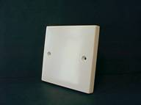
BLANKING PLATES

SINGLE WHITE
FROM…50p each 120923(10)

DOUBLE WHITE
FROM…80p each 120924(10)

DRY LINING BOXES

SINGLE
FROM …50p each 131775(20)

DOUBLE
FROM… 85p each 110743(10)

CEILING ROSES
FROM… 99p each 127468(10)

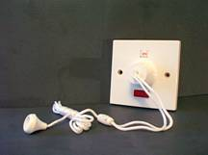
CEILING SWITCHES

6A LIGHTING PULL-SWITCH
FROM… £1.60 each 127471(10)

45A DP SHOWER PULL-SWITCH
FROM… £5.00 each 127302(5)

50A DP SHOWER PULL-SWITCH
ONLY … £8.99 each 131772

CONNECTOR STRIP

15A STRIP OF 12-WAY
FROM… 50p each 102708(10)

DOWNLIGHTERS

LOW VOLTAGE
FROM… £2.99 each
MAINS VOLTAGE
FROM… £3.99 each

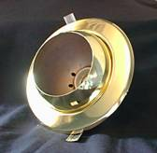

BRASS ROUND EYEBALL R050
ONLY… £4.99 each 129711

JUNCTION BOXES
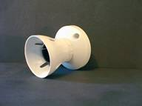
LAMPHOLDERS
BC BATTEN T2 RATED (100W)
FROM… 99p 127486(10)

LIGHT FITTINGS
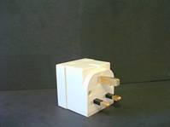
MAINS ADAPTORS

2-WAY UNFUSED
FROM… 80p each 122918(10)

3-WAY FUSED
FROM… £1.60 each 127769(10)

MAINS LEADS
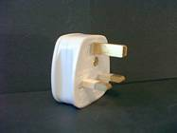

PLUGTOPS

13A FUSED
FROM…50p 130786(50)

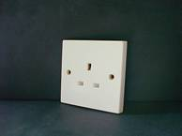
SOCKET OUTLETS
1-GANG UNSWITCHED
FROM… £1.40 each 127473(10)

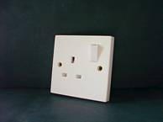

1-GANG SWITCHED
FROM… £1.60 each 120920(10)
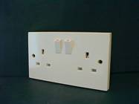
2-GANG UNSWITCHED
FROM… £2.40 each 127474(5)

2-GANG SWITCHED
FROM… £1.99 each 127465(5)

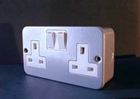

2-GANG SWITCHED
METAL-CLAD WITH SURFACE BOX
ONLY… £7.99 each 129257

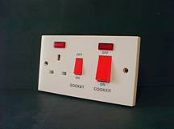
COOKER SWITCHSOCKET WITH
45A D.P. SWITCH AND
TWO NEON INDICATORS
ONLY… £7.99 each 127111

COOKER SWITCHSOCKET WITH
45A D.P. SWITCH
ONLY… £6.99 127110

SOCKET PLATES SIGNAL
TV CO-AX WHITE
SINGLE
FROM… 99p 127511(10)

SPUR OUTLET PLATES

20A FLEX CABLE OUTLET
ONLY… £1.50 each 129709

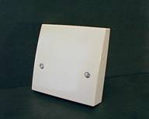

45A COOKER CABLE OUTLET
FROM… £3.10 each 127070

FUSED SPUR (3A)
ONLY… £2.65 each 127020

FUSED SPUR (13A)
ONLY… £2.65 each 127021
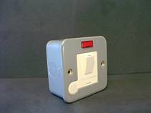
FUSED, SWITCHED SPUR OUTLET
WITH NEON INDICATOR
AND OPTIONAL FLEX CABLE OUT
INCLUDING SURFACE BOX
ONLY… £5.50 each 129494

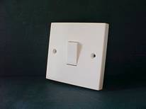
SWITCHES

LIGHTING PLATESWITCH WHITE
1-GANG 1-WAY
FROM… 50p each 127472(10)

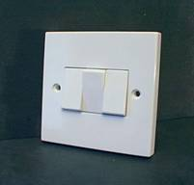

LIGHTING PLATESWITCH WHITE
3-GANG 2-WAY
FROM… £2.50 each 127057

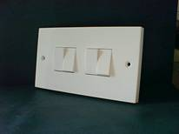
LIGHTING PLATESWITCH WHITE
4-GANG 2-WAY
ONLY… £3.25 each 127383

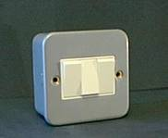
LIGHTING SWITCHES
METAL-CLAD WITH SURFACE BOX
2-GANG 2-WAY
ONLY… £3.99 each 127057
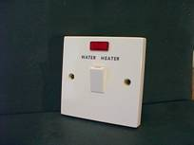

20A DP SWITCH
MARKED “WATER HEATER”
AND WITH NEON INDICATOR
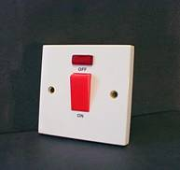
ONLY… £3.50 each 129255

45A D.P. COMPACT SWITCH
WITH NEON INDICATOR
ONLY… £4.50 each 127068

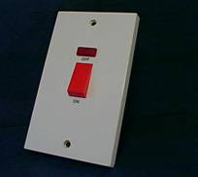
45A D.P. SWITCH
WITH NEON INDICATOR
ONLY… £5.99 each 127387

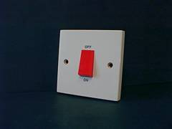

45A D.P. COMPACT SWITCH
ONLY… £3.99 each 127069

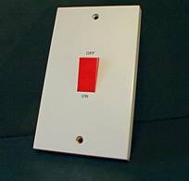

45A D.P. SWITCH
ONLY… £4.99 each 127386

DIMMERS

1G1W (250W) 6.50 132239
1G1W (400W) 6.99 132240
1G2W (400W) 7.99 132241
2G2W (250W+250W) 11.99 132242

REMEMBER ALL OUR PRICES INCLUDE VAT

If you can’t make it into our shop call us on 01389 732588 and we can arrange to have any items sent to your address.
Under £100 carriage: £6.50
Over £100 carriage FREE!

Credit Card payment accepted.
Paypal payment accepted.
Telephone payment accepted.
Cheques accepted.

